Experiment 2.1

Student Name: Nabha Varshney UID: 20BCS4995
Branch: B.E.-CSE Section/Group: 20BCS704-A
Semester: 6th Date of Performance: 04/04/2023
Subject Name: Internet of Things Lab Subject Code: 20CSP-358

- Aim:

To measure the distance of an object using an ultrasonic sensor.

- Objective:
- Learn about interfacing.
- Learn about IoT programming.
- Requirements:
- Arduino Uno R3 board
- Ultrasonic sensor (HC-SR04)
- 16×2 LCD I2C Display
- Jumper Wires

- Procedure:

Arduino:
It is an open-source electronics platform. It consists ATmega328 8-bit Micro controller. It can be able to read inputs from different sensors & we can send instructions to the micro controller in the Arduino. It provides Arduino IDE to write code & connect the hardware devices like Arduino boards & sensors.

Ultrasonic Sensor:
An ultrasonic Sensor is a device used to measure the distance between the sensor and an object without physical contact.This device works based on time-to-distance conversion.

Setup

- Connect the Echo pin of the sensor to the D2 pin of the Arduino.
- Connect the Trig pin of the sensor to the D3 pin of the Arduino.
- Navigate to Tools and select board and port.
- Verify and compile the code, then upload the code to the Arduino Uno R3 board.
- Monitor the output in the Serial monitor (Set the baud rate as 9600). To open Serial monitor Tools>Serial Monitor or (Ctrl+Shift+M).

- Code/Program:

const int pingPin = 3; // Trigger Pin of Ultrasonic Sensor
const int echoPin = 2; // Echo Pin of Ultrasonic Sensor
const int led = 13;
void setup() {
Serial.begin(9600); // Starting Serial Terminal
pinMode(led,OUTPUT);
pinMode(8, OUTPUT);
}

void loop() {
long duration, inches, cm;
pinMode(pingPin, OUTPUT);
digitalWrite(pingPin, LOW);
delayMicroseconds(2);

digitalWrite(pingPin, HIGH);
delayMicroseconds(10);
digitalWrite(pingPin, LOW);
pinMode(echoPin, INPUT);
duration = pulseIn(echoPin, HIGH);
inches = microsecondsToInches(duration);
cm = microsecondsToCentimeters(duration);
Serial.print(inches);
Serial.print("in, ");
Serial.print(cm);
Serial.print("cm");
Serial.println();

if(cm <50)
{
digitalWrite(led, HIGH);
digitalWrite(8,HIGH);
}
else
{
digitalWrite(led, LOW);
digitalWrite(8,LOW);
}
delay(1000);
}

long microsecondsToInches(long microseconds) {
return microseconds / 74 / 2;
}
long microsecondsToCentimeters(long microseconds) {
return microseconds / 29 / 2;
}

FIGURE: CIRCUIT

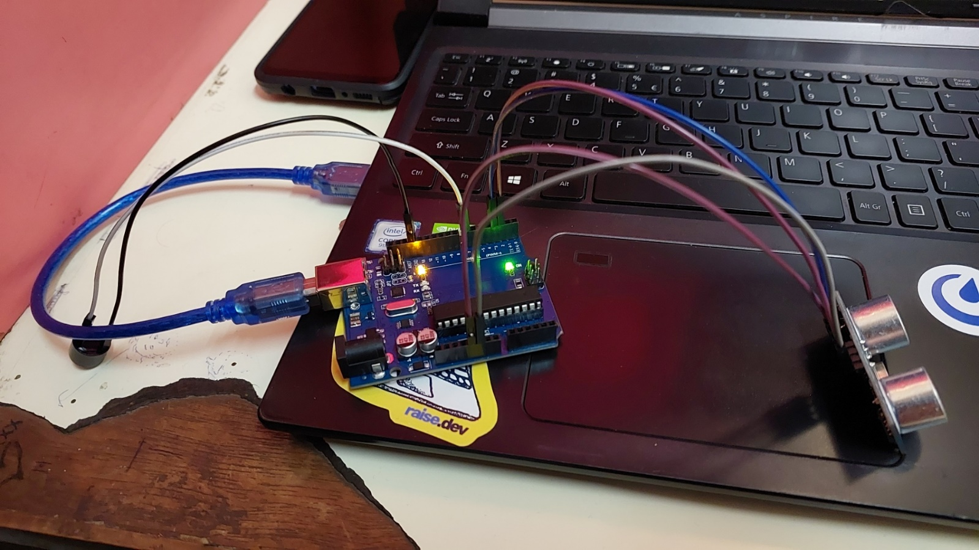
FIGURE: CIRCUIT WITH BUZZER

Learning outcomes (What I have learnt):
- The furthest we can record is 1197 cm.
- We put conditions such that when the distance is less than 50 cm it will blink the led at PORT number 13.
- Another observation we have noticed is by attaching a buzzer with above condition we can make a security device which will start ringing whenever something approaches closer than 50 cm.

Evaluation Grid (To be created as per the SOP and Assessment guidelines by the faculty):
Sr. No. | Parameters | Marks Obtained | Maximum Marks
1.

